**BANGALOREUNIVERSITY**

Bangalore – 560056, Karnataka State, INDIA

**A PROJECT REPORT ON**

**“RESTAURANT MANAGEMENT SYSTEM”**

Submitted

In a parallel fulfilment of the requirement for the degree V semester

**BACHELOR OF COMPUTER APPLICATIONS**

**UNDER THE GUIDANCE OF**

Mrs. Nagalambika S

**LECTURER OF DEPARTMENT B.C.A**

Submitted By

Chaitra.C



**EAST WEST COLLEGE OF MANAGEMENT**

#63, off .Magadi Main Road, Vishwaneedam Post, Bangalore – 560091

**RESTAURANT MANAGEMENT SYSTEM**

**ACKNOWLEDGEMENT**

It is the great pleasure to express our thanks and gratitude to all those who have been associated with this project “RESTAURANT MANAGEMENT SYYSTEM”.

I take this opportunity to express my deep sense of gratitude to our principal Prof. NAGESH RAO for the

Valuable guidance, keen interest during the course of studies.

We would like to thank Mr. H M Shivakumar, our head of Department East West College for unfailing support and guidance throughout the course of the project.

In the same respect we would like to thank our project guide Mrs. Nagalambika S and other B.C.A facility for extending their helping hand in every way and guiding us.

Thank you

Submitted By:

Poojitha Bhat N

Chaitra C

### ABSTRACT

This Project represents the “RESTAURANT MANAGEMENT SYSTEM” and is based on the powerful tool –Visual Basic 6.0 as Front end with Microsoft Access as the Back end. In this preparation of project sincere and Ernest as been made to present the matter contain herein a Form, which is simple and easy to understand.

Since the restaurant is the place where every common people visit and it associates with the lives of common people and their day to day food, so we decided to work on this project.

The manual ordering of the records is time consuming and prone to errors. The purpose of this project is to reduce time for ordering the food for the particular table in a restaurant.

CONTENT

1. Synopsis
   1. Introduction
   2. Software Hardware Requirements
   3. About the project
2. Developmental tools
   1. Introduction to Visual Basic 6.0
   2. Introduction to MS Access
3. System Overview
4. System Design
   1. Data Flow Diagram
5. Snapshots
6. Coding
7. Conclusion
8. Bibliography

**CHAPTER-1**

SYNOPSIS

**CHAPTER – 1**

**SYNOPSIS**

* 1. **INTRODUCTION**

Restaurant Management System is concerned with the customers, employee and about foods. This include department of Employee details, Customer details and keeps the records of sales, bills, food items. The user must provide a valid username and password before accessing the database. This application software has a user friendly graphical interface which provide user with the option like add, delete, save, modify and displaying of data. It helps to manage all the activities of software it also includes telephone booking.

* 1. HARDWARE SOFTWARE REQUIREMENT
     1. HARDWARE REQUIREMENT

PROCESSOR : Intel

MEMOY : 2GB, 80 GB

KEYBOARD : Standard Keyboard

MOUSE : Standard USB Mouse

* + 1. SOFTWARE REQUIREMENTS

OPERATING SYSTEM : Windows 7

FRONT END : Visual Basic 6.0

BACK END : MS Access

* 1. ABOUT THE PROJECT
     1. Aim
* To provide quality support to information technology and its enabled services.
* To provide wide range of ideas and thoroughly to the environment about the development of information technology and its fields.
  + 1. Motto
* Quality management at affordable cost for all
  + 1. Benefits
* Management project will remarkably reduce 95% f manual work. It will be hassle free and reduce the wastage of paper.
* This project is beneficial to the organization, Restaurant industries and Hotel industries.
* This project offers unlimited report facility and is cost effective.  
  + 1. Objects of the project
* This application software helps to maintain the records of customers, employee, foods, sales, print bills, phone booking. This application software produces the accurate results with respect to the calculations.

**CHAPTER 2**

DEVELOPMENT TOOLS

CHAPTER 2

DEVELOPMENTAL TOOLS

2.1 INTRODUCTION TO VISUAL BASIC 6.0

Microsoft Visual Basic is the fastest and easiest way to create application for MS Window. Where one can be experienced professional or brand new to windows programming. Visual basic provides a complete set of tools to simplify rapid application development.

The word “VISUAL” refers to the methods used to create graphical user interface (GUI). Rather than writing numerous line of code to describe appearance and location of interface element rebuilt objects can simplify be dragged and dropped into forms.

The word “BASIC” refers to the basic (Beginners All Purpose Symbolic Introduction Code). It’s the language used by more programmers than the other language in the history of computing. Visual basic has evolved from the original basic language and now contains several hundred statements, functions and keywords many of which directly relate to the windows GUI.

Beginners can create application by learning just a few keywords, yet the power of the language allows professionals to accompalish using any others windows programming language.

The Visual Basic Programming Language it is not only for programming it is also used to combine Microsoft excels SQL server and many other Windows Application. The Visual Basic Script for internet programming is a subset to the visual basic language. The investment made in learning visual basic will carry over to these other areas.

Active-X Technologies allow using the functionality provided by nthe other application such as MS word processor; MS excel spread sheet and other windows application. These applications and object created can be internet capabilities make it easy to provide access to document and application across the internet from within your application the finished application is true .EXE file that uses a runtime dynamic link library(*.dll)

**IDE-**the working environment in Visual Basic is referred to as the integrated development because it integrators much different function such as design, editing, compiling and debugging within a common environment. In most traditional development tools each of these functions would operate as separate programming, each with its own interface.

IDE consists of following elements.

**MENU BAR-** Displays the commands you used to work with Visual Basic. Besides the standard file, edit, windows and help menus are provided to access functions specific to the programming such as project, format and debug

**CONTEXT MENUS-** Contains shortcut to frequently perform the actions.

**TOOLBARS** - Provide a set of tools that is used at design time to place control on a form in additions to the default toolbox layout, custom layout can also be created by selecting add tab from the context menu and adding controls to the resulting tab.

**PROJECT EXPLORER WINDOW**- Lists the forms and modules in your current project. A project may contain many forms or a single form.

**PROPERTIES WINDOW**- Lists the properties setting for the selecting form or control a property is characteristic of an object such as size, caption or color.

**OBJECT BROWSER**- lists object available for use in a project and give a quick way to navigate through code. The object browser can be used to explorer in visual basic and other application and can see methods and properties which are available for those objects, and we can use it for our application.

**FORM DESIGNER**- Servers as windows that are customized to design the interface of the application, background graphics and pictures can be added to our form create the look which you want. The each form has its own designers.

**CODE EDITOR WINDOW**- Serves as an editor for entering application code. A separate code editor window is created for each forms or code module of the application.

**FORM LAYOUT WINDOW-** The form layout window allows position of the application using a small graphical representation of the screen.

**IMMEDIATE LOCALS AND WATCH WINDOWS**- These additional windows provided for use in debugging the application. They are only available when the application is running within the IDE.

Visual Basic provides a great deal of flexibility, allowing configuring the working environment to best suit the programmer’s individual style. A choice can be made between a single and multiple document interfaces, and the size and positioning of the various IDE elements can be adjusted. The layout will be present between sessions of VB.

VB’s main point is the ease with which it allows the user to create a graphical

And a attractive programs with little coding by the programmer. Unlike any others languages that may take hundreds of lines of code this has the graphical environment where much of the code is auto generated by the VB program. In order to understand how this happens it is necessary to understand the major concept, objects and tools used by the VB. The main tool in VB program is called form. This form appears as soon as the VB application opens. This is how the form looks like.

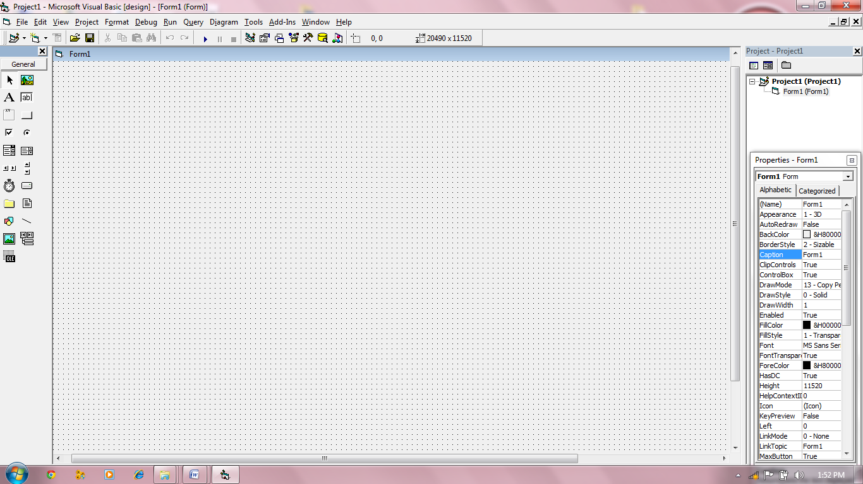

Fig (2.1)

2.2 INTRODUCTION TO MS ACCESS (AS A BACKEND)

INTRODUCTION- Access is a relational database management system (RDBMS) that you use to store and manipulate large amount of information, because it is the power development environment. Access is equally appropriate for novices and Misprofessionals. Bernadette user who works primarily with MS Word to produce documents can use access to create a database of mailing list information that he can merge with word documents. Nadine professionals use access to develop a database application that track customer and order information, which data entry people can operate without ever knowing they are in access.

**GENERAL OVER VIEW OF DATABASE**- Database contains data that is used to store all the elements that you to store and manipulate data. The extension of MS Access file is *.mdb.

**TABLE**- A table is the only structure within a database that can hold data as its own format and stores the data in the physical device as per the format. A table contains entries in it, where each row is one entry in a table can also append to a table. The table can be indexed on one or more of its fields, in ascending or descending order**.**

**INDEX**- Index never contains all of the field’s entries of the table. It only contains a subset. It also in all likeness does not store in a same order as its entries were made. An index is stored and contains a pointer to the record in the table. Sorting the index allows you it find the kind of data you want in a fast and efficient manner.

**CREATING AND HANDLING A DATABASE IN MS ACCESSS**- In MS Access, creating a database is simple, we can do it in many ways. When starting MS Access it prompts if you would like to create or open a blank database, you can click a particular tab and create a new blank database. You can do the same by clicking the button on the tool box. Once you have created a new database you would have to give it a name. In windows 2000, the extension by default is *.mdb.

ADDING TABLE TO A DATABASE- You can add any number of table, forms etc, as mentioned above, create a database & new button of the table tab creates a new table; in properties you click the right button. It shows list of one of them.

Rename Delete

Refresh New Table

New Query Click on the option new table to create table

TABLE DESGIN- The first column (field’s name) contains name of the table. Name gives an idea as to what kind of information the field will hold. The second column contains the data type.

The Basic data types are:

* Text-A short string containing 255 or less character.
* Number – any kind of numeric value.
* Date/time-one of several formats available for date/time.
* Yes/No-Logical or Boolean values.

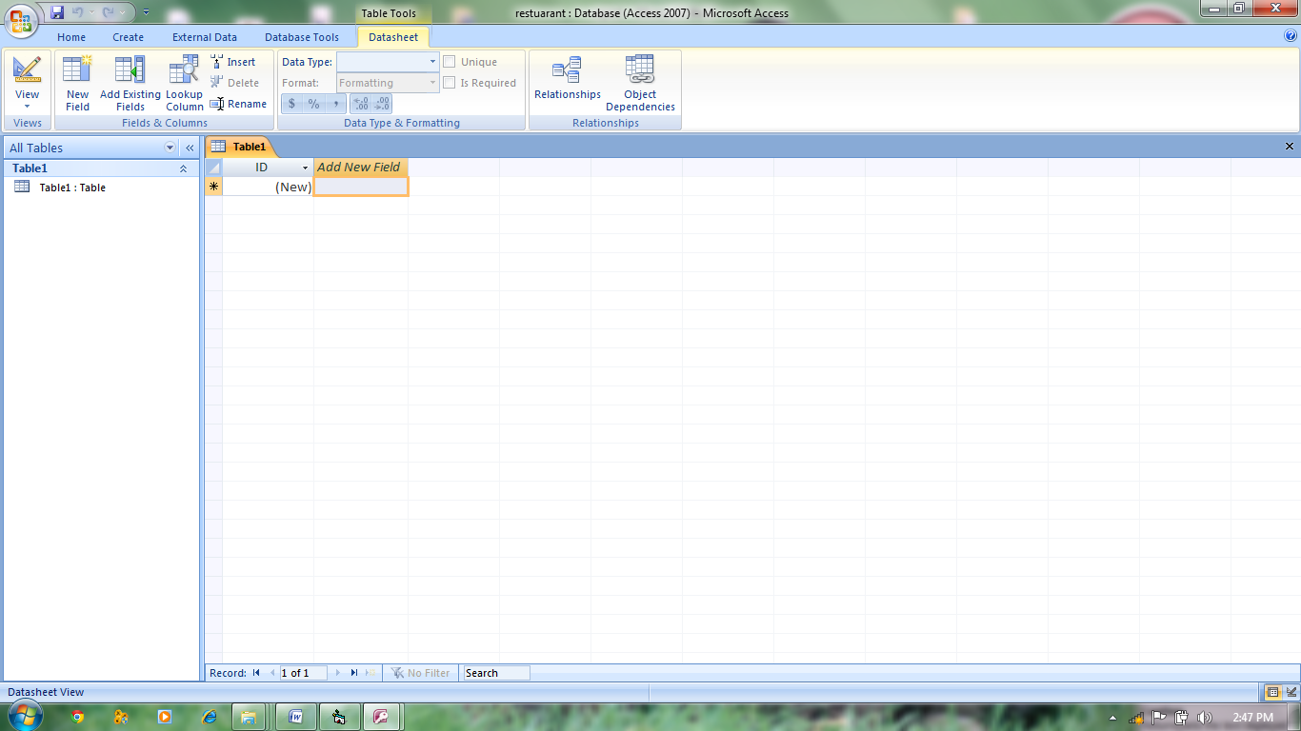

**CHAPTER 3**

SYSTEM OVERVIEW

CHAPTER 3

SYSTEM OVERVIEW

3.1 Authorized function

a) Login.

3.2 Employee function.

a) Add

b) Update

c) Delete

3.3 Employee list function.

a) Show list

b) Print bill

3.4 Customer details function.

a) Order

b) Find customer

c) Add

d) Save

e) Delete

3.5 Customer list function

a) Show list

b) Print bill

3.6 Product Details function

a) Add

b) Delete

c) Save

3.7 Category List function

a) Add

b) Delete

c) Save

3.8 Billing Detail Function

a) Show list

b) Print bill

3.9 Phone booking

a) Add

b) Save

c) Delete

d) Print Bill

CHAPTER 4

SYSTEM DESIGN



**CHAPTER 5**

SNAPSHOTS

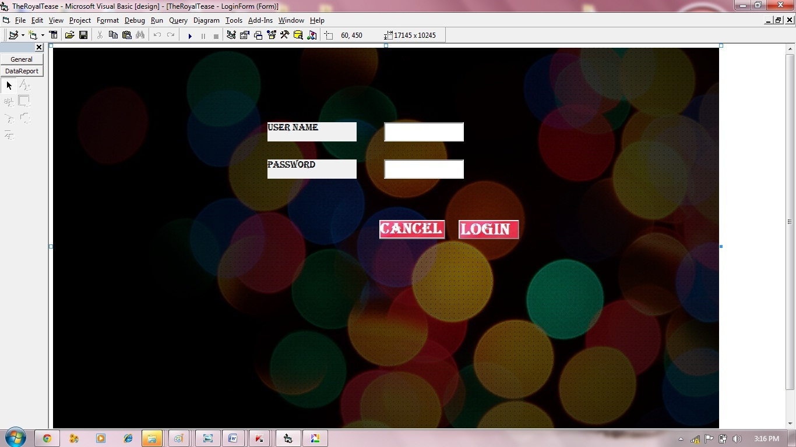

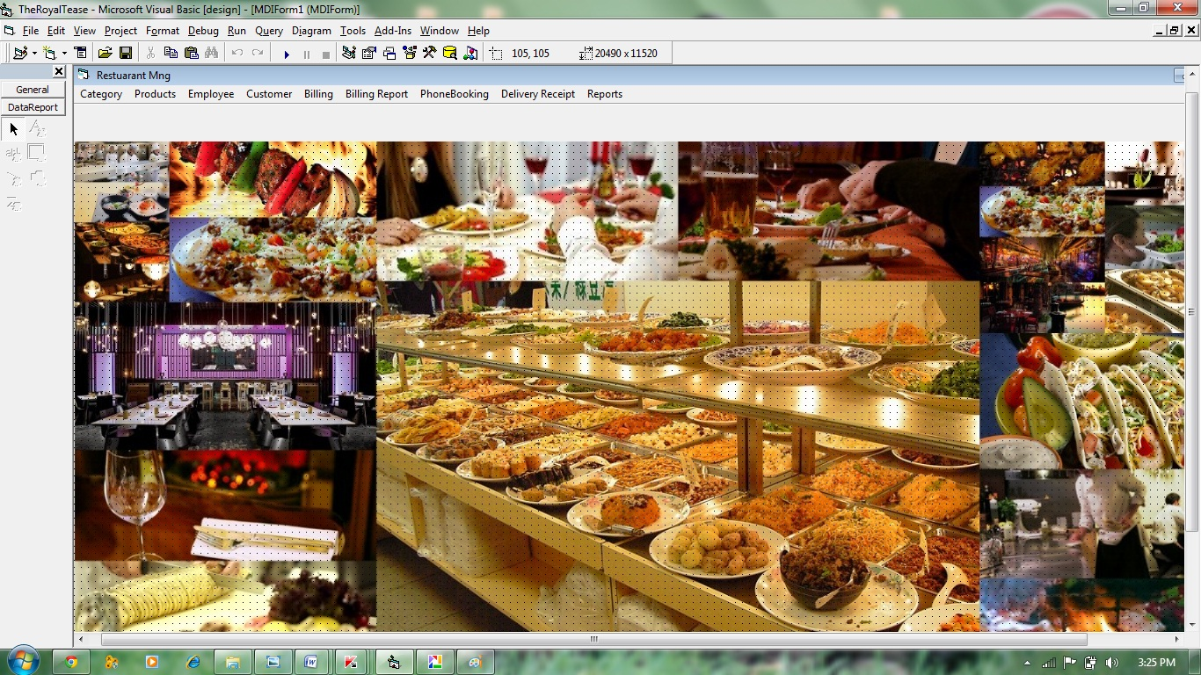

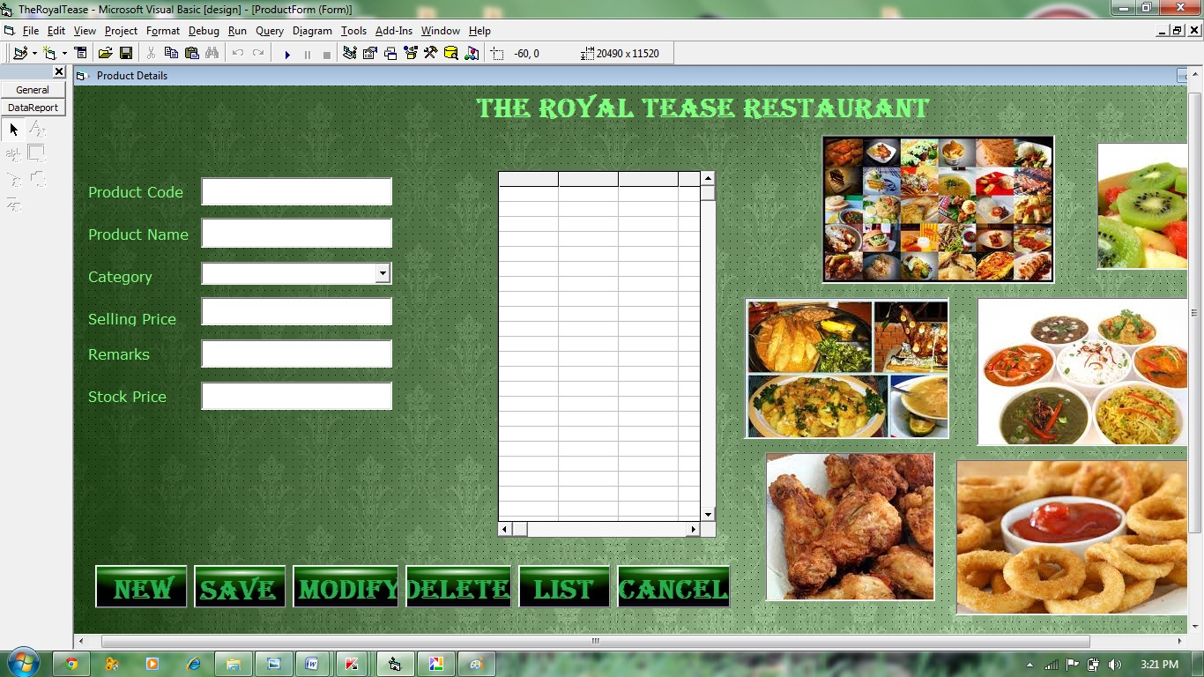

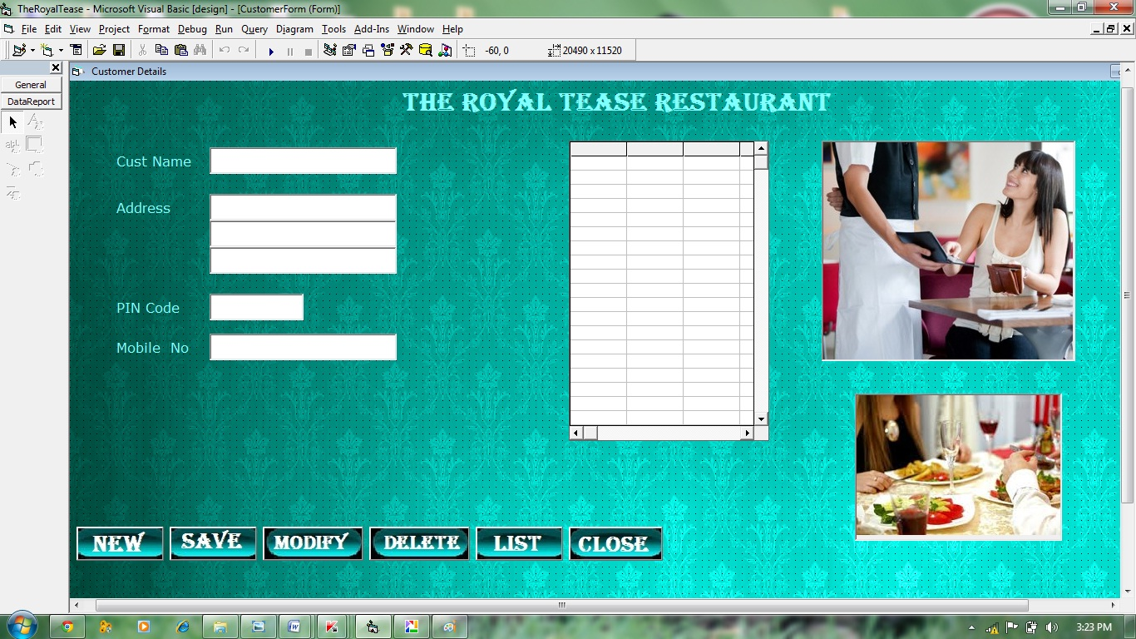

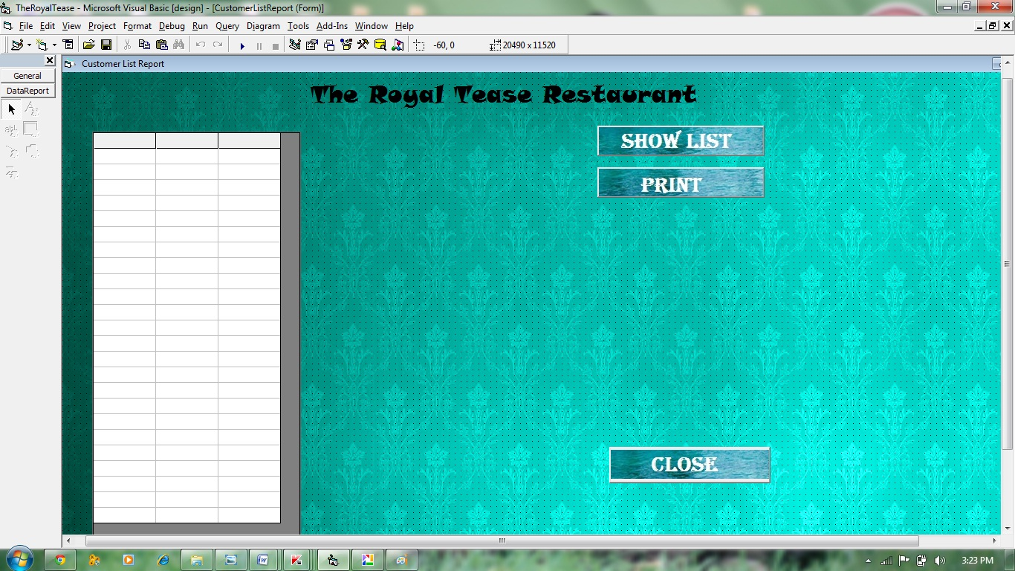

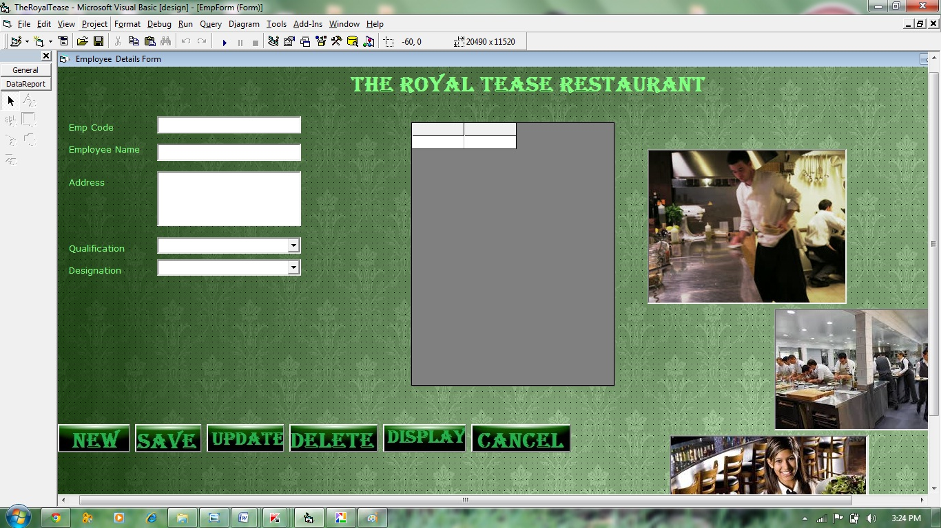

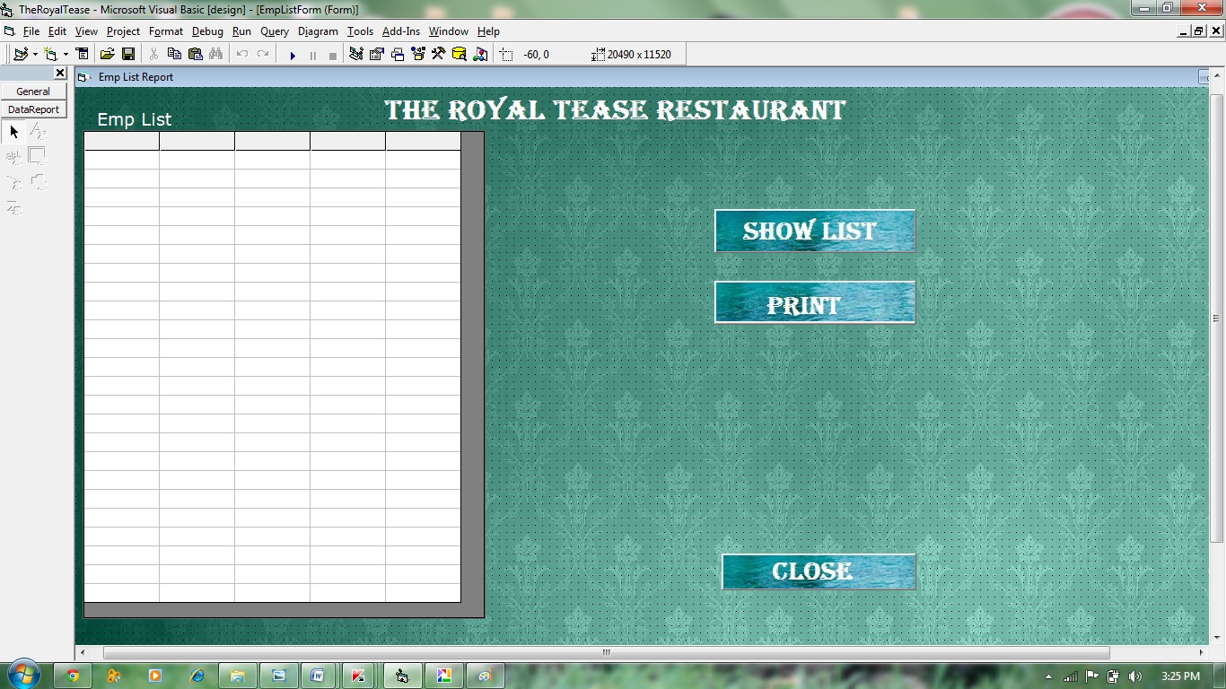

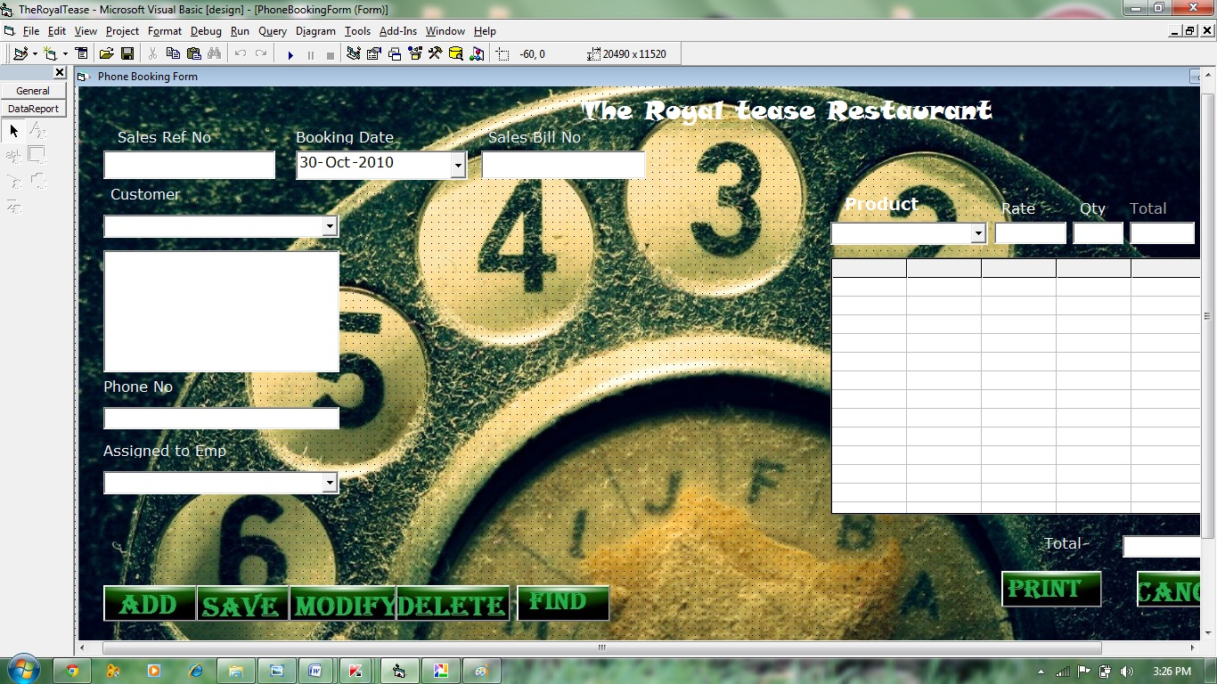

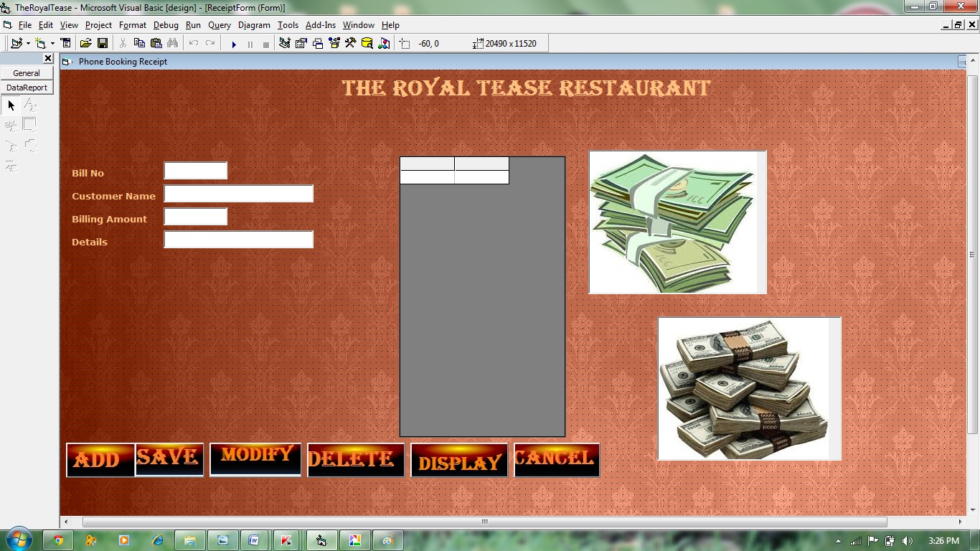

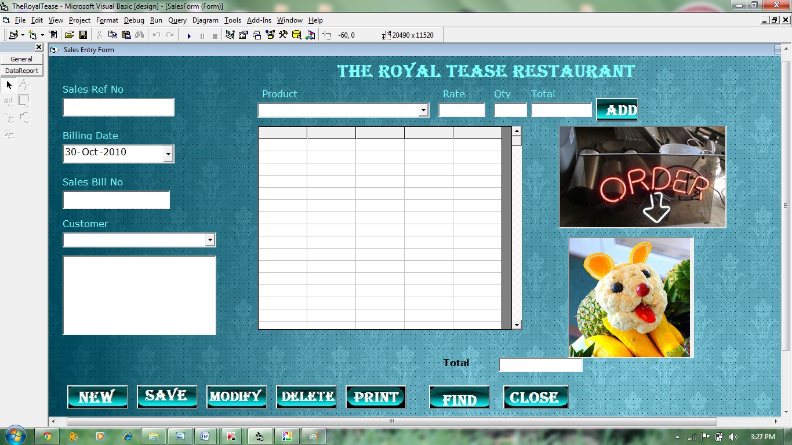

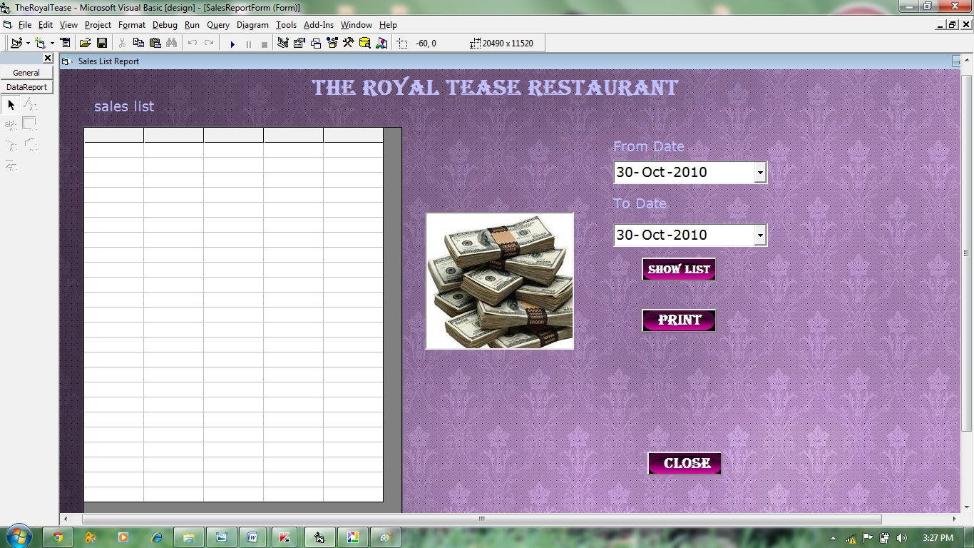

**CHAPTER 6**

CODING

**LOGIN FORM**

Private Sub Command1_Click ()

If tRS.State = 1 Then tRS.Close

tRS.Open "select * from LoginTab where LoginName='" & Text1 & "' and password1 ='" & Text2 & "'", Conn

If tRS.EOF = False Then

Unload Me

MDIForm1.Show

Else

MsgBox "Entered LoginUserName or Password is not correct Please check"

Exit Sub

End If

End Sub

Private Sub Form_Load()

Me.Height = 5175

Me.Width = 7440

Conn. Open "Provider=Microsoft.Jet.OLEDB.4.0;Data Source=" & App. Path & "\RestuarantData.mdb;Persist Security Info=False"

End Sub

**CATEGORY FORM**

Dim CatVar As String

Private Sub Butclose_Click()

Unload Me

End Sub

Private Sub butDelete_Click()

If Text1 = "" Then

MsgBox "Please enter the Category Name"

Exit Sub

End If

If vbNo = MsgBox("Are you sure you want to Delete this record", vbYesNo, "Delete Record") Then Exit Sub

Conn. Execute "delete from Category Tab where Category Name='" & CatVar & "'"

ButNew.Enabled = True

ButSave.Enabled = False

ButModify.Enabled = False

ButDelete.Enabled = False

ButList_Click

End Sub

Private Sub ButList_Click()

MSF.Clear

MSF.ColWidth(0) = 2400

MSF.ColWidth(1) = 2500

MSF.TextMatrix(0, 0) = "Category Name"

MSF.TextMatrix(0, 1) = "Details"

I = 1

If tRS.State = 1 Then tRS.Close

tRS.Open "select CategoryName, Details from Category Tab order by Category Name", Conn

Do While tRS.EOF = False

MSF.TextMatrix (I, 0) = tRS (0) & ""

MSF.TextMatrix (I, 1) = tRS (1) & ""

I = I + 1

MSF.Rows = I + 5

tRS.MoveNext

Loop

End Sub

Private Sub butModify_Click ()

If Text1 = "" Then

MsgBox "Please enter the Category Name"

Exit Sub

End If

Conn. Execute "delete from Category Tab where Category Name='" & CatVar & "'"

Conn. Execute "insert into Category Tab values ('" & UCase (Text1) & "','" & Text2 & "')"

ButNew.Enabled = True

ButSave.Enabled = False

ButModify.Enabled = False

ButDelete.Enabled = False

ButList_Click

End Sub

Private Sub ButNew_Click ()

Text1 = ""

Text2 = ""

ButNew.Enabled = False

ButSave.Enabled = True

ButModify.Enabled = False

ButDelete.Enabled = False

End Sub

Private Sub butSave_Click ()

If Text1 = "" Or Text2 = "" Then

MsgBox "Please fill details"

Exit Sub

End If

Conn. Execute "insert into Category Tab values ('" & UCase (Text1) & "','" & Text2 & "')"

ButNew.Enabled = True

ButSave.Enabled = False

ButModify.Enabled = False

ButDelete.Enabled = False

ButList_Click

End Sub

Private Sub Form_Load ()

ButList_Click

End Sub

Private Sub MSF_DblClick ()

If MSF.TextMatrix (MSF.Row, 0) = "" Then Exit Sub

CatVar = MSF.TextMatrix (MSF.Row, 0)

If tRS.State = 1 Then tRS.Close

tRS.Open "select * from Category Tab where Category Name='" & CatVar & "'", Conn

If tRS.EOF = False Then

Text1 = tRS (0) & ""

Text2 = tRS (1) & ""

ButNew.Enabled = True

ButSave.Enabled = False

ButModify.Enabled = True

ButDelete.Enabled = True

End If

End Sub

**PRODUCT FORM**

Dim ProdVar As String

Function CheckNum (KeyNum)

If KeyNum = 8 Then CheckNum = KeyNum: Exit Function

If KeyNum < 46 Or KeyNum > 57 Then

CheckNum = 0

MsgBox ("Please Enter Numbers Only")

Else

CheckNum = KeyNum

End If

End Function

Private Sub Butclose_Click ()

Unload Me

End Sub

Private Sub butDelete_Click ()

If Text1 = "" Then

MsgBox "Please enter the Product Code"

Exit Sub

End If

If vbNo = MsgBox("Are you sure you want to Delete this record", vbYesNo, "Delete Record") Then Exit Sub

Conn. Execute "delete from ProductTab where ProdCode='" & ProdVar & "'"

ButNew.Enabled = True

ButSave.Enabled = False

ButModify.Enabled = False

ButDelete.Enabled = False

ButList_Click

End Sub

Private Sub ButList_Click ()

MSF.Clear

MSF.ColWidth (0) = 2400

MSF.ColWidth (1) = 2500

MSF.TextMatrix (0, 0) = "Product Code"

MSF.TextMatrix (0, 1) = "Category"

I = 1

If tRS.State = 1 Then tRS.Close

tRS.Open "select ProdCode, pCat from ProductTab order by ProdCode", Conn

Do While tRS.EOF = False

MSF.TextMatrix (I, 0) = tRS (0) & ""

MSF.TextMatrix (I, 1) = tRS (1) & ""

I = I + 1

MSF.Rows = I + 5

tRS.MoveNext

Loop

End Sub

Private Sub butModify_Click()

If Text1 = "" Then

MsgBox "Please enter the Product Code"

Exit Sub

End If

Conn. Execute "delete from ProductTab where ProdCode='" & ProdVar & "'"

Conn. Execute "insert into ProductTab values('" & UCase(Text1) & "','" & Text2 & "','" & Combo1 & "'," & Val(Text3) & "," & Val(Text4) & ",'" & Text5 & "')"

ButNew.Enabled = True

ButSave.Enabled = False

ButModify.Enabled = False

ButDelete.Enabled = False

ButList_Click

End Sub

Private Sub ButNew_Click()

Text1 = ""

Text2 = ""

Text3 = ""

Text4 = ""

Text5 = ""

Text6 = ""

ButNew.Enabled = False

ButSave.Enabled = True

ButModify.Enabled = False

ButDelete.Enabled = False

End Sub

Private Sub butSave_Click()

If Text1 = "" Or Text2 = "" Or Text4 = "" Or Text5 = "" Or Combo1 = "" Then

MsgBox "Please enter complete details"

Exit Sub

End If

Conn. Execute "insert into ProductTab values('" & UCase(Text1) & "','" & Text2 & "','" & Combo1 & "'," & Val(Text3) & "," & Val(Text4) & ",'" & Text5 & "')"

ButNew.Enabled = True

ButSave.Enabled = False

ButModify.Enabled = False

ButDelete.Enabled = False

ButList_Click

End Sub

Private Sub Form_Load()

ButList_Click

If tRS.State = 1 Then tRS.Close

tRS.Open "select CategoryName,Details from Category Tab order by Category Name", Conn

Do While tRS.EOF = False

Combo1.AddItem (tRS(0))

tRS.MoveNext

Loop

End Sub

Private Sub MSF_DblClick()

If MSF.TextMatrix(MSF.Row, 0) = "" Then Exit Sub

ProdVar = MSF.TextMatrix(MSF.Row, 0)

If tRS.State = 1 Then tRS.Close

tRS.Open "select * from ProductTab where ProdCode='" & ProdVar & "'", Conn

If tRS.EOF = False Then

Text1 = tRS(0) & ""

Text2 = tRS(1) & ""

Combo1 = tRS(2) & ""

Text3 = tRS(3) & ""

Text4 = tRS(4) & ""

Text5 = tRS(5) & ""

ButNew.Enabled = True

ButSave.Enabled = False

ButModify.Enabled = True

ButDelete.Enabled = True

End If

End Sub

Private Sub Text4_KeyPress(KeyAscii As Integer)

KeyAscii = CheckNum(KeyAscii)

End Sub

Private Sub Text5_KeyPress(KeyAscii As Integer)

If KeyAscii = 13 Then

Text5.SetFocus

ElseIf (KeyAscii < 65 And KeyAscii <> 8 And KeyAscii <> 32) Or (KeyAscii > 90 And KeyAscii < 97) Or (KeyAscii > 122) Then

KeyAscii = 0

MsgBox ("Please Enter char")

End If

End Sub

**EMPLOYEE FORM**

Dim eCodeVar As String

Private Sub Butclose_Click()

Unload Me

End Sub

Private Sub butDelete_Click()

If Text1 = "" Then

MsgBox "Please Enter The Employee Code"

Exit Sub

End If

Conn. Execute "delete from EmpTab where EmpCode ='" & eCodeVar & "'"

butSave.Enabled = False

ButNew.Enabled = True

butModify.Enabled = False

butDelete.Enabled = False

End Sub

Private Sub ButDis_Click()

MSF.Clear

MSF.Cols = 2

MSF.TextMatrix(0, 0) = "Emp Code"

MSF.TextMatrix(0, 1) = "Emp Name"MSF.ColWidth(0) = 2000

MSF.ColWidth(1) = 2000

I = 1

If tRS.State = 1 Then tRS.Close

tRS.Open "select * from EmpTab order by EmpCode", Conn

Do While tRS.EOF = False

MSF.TextMatrix(I, 0) = tRS(0)

MSF.TextMatrix(I, 1) = tRS(1)

tRS.MoveNext

I = I + 1

MSF.Rows = I + 5

Loop

End Sub

Private Sub butModify_Click()

If Text1 = "" Then

MsgBox "Please Enter The Employee Code"

Exit Sub

End If

Conn. Execute "delete from EmpTab where EmpCode ='" & eCodeVar & "'"

Conn. Execute "insert into EmpTab values('" & Text1 & "','" & Text2 & "','" & Text3 & "','" & Combo1 & "','" & Left(Combo2, 4) & "')"

butSave.Enabled = False

ButNew.Enabled = True

butModify.Enabled = False

butDelete.Enabled = False

End Sub

Private Sub ButNew_Click()

Text1.Text = ""

Text2.Text = ""

Text3.Text = ""

butSave.Enabled = True

ButNew.Enabled = False

butModify.Enabled = False

butDelete.Enabled = False

End Sub

Private Sub butSave_Click()

If Text1 = "" Or Text2 = "" Or Text3 = "" Or Combo1 = "" Or Combo2 = "" Then

MsgBox "Please fill all the details"

Exit Sub

End If

Conn. Execute "insert into EmpTab values('" & Text1 & "','" & Text2 & "','" & Text3 & "','" & Combo1 & "','" & Left(Combo2, 4) & "')"

butSave.Enabled = False

ButNew.Enabled = True

butModify.Enabled = False

butDelete.Enabled = False

End Sub

Private Sub Form_Load()

ButDis_Click

End Sub

Private Sub MSF_DblClick()

If MSF.TextMatrix(MSF.Row, 0) = "" Then Exit Sub

eCodeVar = MSF.TextMatrix(MSF.Row, 0)

If tRS.State = 1 Then tRS.Close

tRS.Open "select * from EmpTab where EmpCode ='" & eCodeVar & "'", Conn

If tRS.EOF = False Then

Text1 = tRS(0)

Text2 = tRS(1)

Text3 = tRS(2)

Combo1 = tRS(3)

Combo2 = tRS(4)

End If

butSave.Enabled = False

ButNew.Enabled = True

butModify.Enabled = True

butDelete.Enabled = True

End Sub

Private Sub Text2_KeyPress(KeyAscii As Integer)

If KeyAscii = 13 Then

Text5.SetFocus

ElseIf (KeyAscii < 65 And KeyAscii <> 8 And KeyAscii <> 32) Or (KeyAscii > 90 And KeyAscii < 97) Or (KeyAscii > 122) Then

KeyAscii = 0

MsgBox ("Please Enter char")

End If

End Sub

**CUSTOMER FORM**

Dim CustVar As String

Private Sub Butclose_Click()

Unload Me

End Sub

Private Sub butDelete_Click()

If Text1 = "" Then

MsgBox "Please enter the Customer Name"

Exit Sub

End If

If vbNo = MsgBox("Are you sure you want to Delete this record", vbYesNo, "Delete Record") Then Exit Sub

Conn. Execute "delete from customerTab where custName='" & CustVar & "'"

ButNew.Enabled = True

ButSave.Enabled = False

ButModify.Enabled = False

ButDelete.Enabled = False

ButList_Click

End Sub

Private Sub ButList_Click()

MSF.Clear

MSF.ColWidth(0) = 2400

MSF.ColWidth(1) = 2500

MSF.TextMatrix(0, 0) = "Customer Name"

MSF.TextMatrix(0, 1) = "Address"

I = 1

If tRS.State = 1 Then tRS.Close

tRS.Open "select custName,add3 from CustomerTab order by custname", Conn

Do While tRS.EOF = False

MSF.TextMatrix(I, 0) = tRS(0) & ""

MSF.TextMatrix(I, 1) = tRS(1) & ""

I = I + 1

MSF.Rows = I + 5

tRS.MoveNext

Loop

End Sub

Private Sub butModify_Click()

If Text1 = "" Then

MsgBox "Please enter the Customer Name"

Exit Sub

End If

Conn. Execute "delete from customerTab where custName='" & CustVar & "'"

Conn. Execute "insert into CustomerTab values('" & UCase(Text1) & "','" & Text2 & "','" & Text3 & "','" & Text4 & "','" & Text5 & "','" & Text6 & "')"

ButNew.Enabled = True

ButSave.Enabled = False

ButModify.Enabled = False

ButDelete.Enabled = False

ButList_Click

End Sub

Private Sub ButNew_Click()

Text1 = ""

Text2 = ""

Text3 = ""

Text4 = ""

Text5 = ""

Text6 = ""

ButNew.Enabled = False

ButSave.Enabled = True

ButModify.Enabled = False

ButDelete.Enabled = False

End Sub

Private Sub butSave_Click()

If Text1 = "" Or Text2 = "" Or Text3 = "" Or Text4 = "" Or Text5 = "" Or Text6 = "" Then

MsgBox "Please enter the Customer Name"

Exit Sub

End If

Conn. Execute "insert into CustomerTab values('" & UCase(Text1) & "','" & Text2 & "','" & Text3 & "','" & Text4 & "','" & Text5 & "','" & Text6 & "')"

ButNew.Enabled = True

ButSave.Enabled = False

ButModify.Enabled = False

ButDelete.Enabled = False

ButList_Click

End Sub

Private Sub Form_Load()

ButList_Click

End Sub

Private Sub MSF_DblClick()

If MSF.TextMatrix(MSF.Row, 0) = "" Then Exit Sub

CustVar = MSF.TextMatrix(MSF.Row, 0)

If tRS.State = 1 Then tRS.Close

tRS.Open "select * from customerTab where custName='" & CustVar & "'", Conn

If tRS.EOF = False Then

Text1 = tRS(0) & ""

Text2 = tRS(1) & ""

Text3 = tRS(2) & ""

Text4 = tRS(3) & ""

Text5 = tRS(4) & ""

Text6 = tRS(5) & ""

ButNew.Enabled = True

ButSave.Enabled = False

ButModify.Enabled = True

ButDelete.Enabled = True

End If

End Sub

Private Sub Text5_KeyPress(KeyAscii As Integer)

KeyAscii = CheckNum(KeyAscii)

End Sub

Private Sub Text6_KeyPress(KeyAscii As Integer)

KeyAscii = CheckNum(KeyAscii)

End Sub

**PHONE BOOKING**

Dim rowNoVar, tranVar As Long

Dim tAmtVar As Long

Private Sub bDate_CallbackKeyDown(ByVal KeyCode As Integer, ByVal Shift As Integer, ByVal CallbackField As String, CallbackDate As Date)

End Sub

Private Sub butAdd_Click()

If Val(TextQty) <= 0 Then

MsgBox "Please enter the Quantity"

Exit Sub

End If

MSF.TextMatrix(rowNoVar, 0) = rowNoVar

MSF.TextMatrix(rowNoVar, 1) = Combo1

MSF.TextMatrix(rowNoVar, 2) = TextRate

MSF.TextMatrix(rowNoVar, 3) = TextQty

MSF.TextMatrix(rowNoVar, 4) = TextTotal

rowNoVar = rowNoVar + 1

tAmtVar = tAmtVar + Val(TextTotal)

Combo1 = ""

TextQty = ""

TextTotal = ""

TextgTotal = ""

TextgTotal = tAmtVar

End Sub

Private Sub Butclose_Click()

Unload Me

End Sub

Private Sub butDelete_Click()

If Text1 = "" Then

MsgBox "RefNo is not valid"

Exit Sub

End If

If vbNo = MsgBox("Are you sure you want to Delete this record", vbYesNo, "Delete Record") Then Exit Sub

Conn. Execute "delete from TranMainTab where TranNo=" & tranVar & ""

Conn. Execute "delete from TranDetailTab where TranNo=" & tranVar & ""

ButNew.Enabled = True

ButSave.Enabled = False

ButModify.Enabled = False

ButDelete.Enabled = False

End Sub

Private Sub ButList_Click()

tranVar = InputBox("Please Enter the Sales Ref No")

If Val(tranVar) <= 0 Then Exit Sub

MSFInit

If tRS.State = 1 Then tRS.Close

tRS.Open "select * from TranMainTab where TranNo=" & tranVar & "", Conn

If tRS.EOF = False Then

Text1 = tRS(0)

bDate = tRS(1)

Text2 = tRS(3)

Combo2 = tRS(4)

tAmtVar = tRS(8)

TextgTotal = tAmtVar

End If

If tRS.State = 1 Then tRS.Close

tRS.Open "select * from TranDetailTab where TranNo=" & tranVar & "", Conn

Do While tRS.EOF = False

MSF.TextMatrix(rowNoVar, 0) = rowNoVar

MSF.TextMatrix(rowNoVar, 1) = tRS(2)

MSF.TextMatrix(rowNoVar, 2) = tRS(3)

MSF.TextMatrix(rowNoVar, 3) = tRS(4)

MSF.TextMatrix(rowNoVar, 4) = tRS(5)

rowNoVar = rowNoVar + 1

MSF.Rows = rowNoVar + 5

tRS.MoveNext

Loop

ButNew.Enabled = True

ButSave.Enabled = False

ButModify.Enabled = True

ButDelete.Enabled = True

End Sub

Private Sub butModify_Click()

If vbNo = MsgBox("Are you sure you want to Modify this record", vbYesNo, "Modify Record") Then Exit Sub

Conn. Execute "delete from TranMainTab where TranNo=" & tranVar & ""

Conn. Execute "delete from TranDetailTab where TranNo=" & tranVar & ""

butSave_Click

End Sub

Private Sub ButNew_Click()

Text1 = ""

Text2 = ""

TextRate = ""

TextQty = ""

TextTotal = ""

TextgTotal = ""

TextAdd = ""

MSFInit

If tRS.State = 1 Then tRS.Close

tRS.Open "select max(tranNo) from TranMainTab", Conn

Text1 = IIf(IsNull(tRS(0)), 1000, tRS(0)) + 1

If tRS.State = 1 Then tRS.Close

tRS.Open "select max(BillNo) from TranMainTab where tranType='S'", Conn

Text2 = IIf(IsNull(tRS(0)), 1000, tRS(0)) + 1

ButNew.Enabled = False

ButSave.Enabled = True

ButModify.Enabled = False

ButDelete.Enabled = False

End Sub

Private Sub butPrint_Click()

If tRS.State = 1 Then tRS.Close

tRS.Open "select * from TranDetailTab where TranNo=" & Val(Text1) & "", Conn

Set SalesbillPrint.DataSource = tRS

SalesbillPrint.Sections("section2").Controls("L1").Caption = Combo2

SalesbillPrint.Sections("section2").Controls("L2").Caption = TextAdd

SalesbillPrint.Sections("section2").Controls("L3").Caption = Text2

SalesbillPrint.Sections("section2").Controls("L4").Caption = DateFormat(bDate)

SalesbillPrint.Sections("section3").Controls("L5").Caption = TextgTotal

SalesbillPrint.Show

End Sub

Private Sub butSave_Click()

If Combo2 = "" Then

MsgBox "Please enter the Supplier Name"

Exit Sub

End If

Conn. Execute "insert into TranMainTab values(" & Val(Text1) & ",'" & DateFormat(bDate) & "','D'," & Val(Text2) & ",'" & Combo2 & "','" & Text3 & "','" & Text4 & "','" & Combo3 & "'," & Val(TextgTotal) & ")"

For I = 1 To rowNoVar - 1

Conn. Execute "insert into TranDetailTab values(" & Val(Text1) & "," & Val(MSF.TextMatrix(I, 0)) & ",'" & MSF.TextMatrix(I, 1) & "'," & Val(MSF.TextMatrix(I, 2)) & "," & Val(MSF.TextMatrix(I, 3)) & "," & Val(MSF.TextMatrix(I, 4)) & ")"

Next

ButNew.Enabled = True

ButSave.Enabled = False

ButModify.Enabled = False

ButDelete.Enabled = False

End Sub

Private Sub Combo1_LostFocus()

If tRS.State = 1 Then tRS.Close

tRS.Open "select sPrice from ProductTab where ProdCode='" & Combo1 & "'", Conn

If tRS.EOF = False Then

TextRate = tRS(0)

Else

TextRate = ""

End If

End Sub

Sub MSFInit()

MSF.Clear

MSF.ColWidth(0) = 600

MSF.ColWidth(1) = 3600

MSF.ColWidth(2) = 1200

MSF.ColWidth(3) = 1200

MSF.ColWidth(4) = 1600

MSF.TextMatrix(0, 0) = "SlNo"

MSF.TextMatrix(0, 1) = "Product Code"

MSF.TextMatrix(0, 2) = "Rate"

MSF.TextMatrix(0, 3) = "Qty"

MSF.TextMatrix(0, 4) = "Total"

rowNoVar = 1

tAmtVar = 0

End Sub

Private Sub Combo2_LostFocus()

If tRS.State = 1 Then tRS.Close

tRS.Open "select Add1,add2,add3,pincode from customerTab where custName='" & Combo2 & "'", Conn

If tRS.EOF = False Then

TextAdd = tRS(0) & "" & vbCrLf

TextAdd = TextAdd & tRS(1) & "" & vbCrLf

TextAdd = TextAdd & tRS(2) & "" & vbCrLf

TextAdd = TextAdd & tRS(3) & "" & vbCrLf

Else

TextAdd = ""

End If

End Sub

Private Sub Form_Load()

bDate = Date

MSFInit

If tRS.State = 1 Then tRS.Close

tRS.Open "select custName from customerTab order by custName", Conn

Do While tRS.EOF = False

Combo2.AddItem tRS(0)

tRS.MoveNext

Loop

If tRS.State = 1 Then tRS.Close

tRS.Open "select Prodcode from ProductTab order by prodcode", Conn

Do While tRS.EOF = False

Combo1.AddItem tRS(0)

tRS.MoveNext

Loop

If tRS.State = 1 Then tRS.Close

tRS.Open "select empCode from empTab order by empcode", Conn

Do While tRS.EOF = False

Combo3.AddItem tRS(0)

tRS.MoveNext

Loop

End Sub

Private Sub Label1_Click()

End Sub

Private Sub Label8_Click()

End Sub

Private Sub MSF_DblClick()

Dim ftNo, ftNo1 As Long

If Not MSF.TextMatrix(MSF.Row, 1) = "" Then

If vbNo = MsgBox("Do you want to remove this Item", vbYesNo, "Remove") Then Exit Sub

ftNo = MSF.Row

ftNo1 = (rowNoVar - 1)

tAmtVar = tAmtVar - MSF.TextMatrix(MSF.Row, 4)

For I = ftNo To ftNo1

MSF.TextMatrix(I, 0) = I

MSF.TextMatrix(I, 1) = MSF.TextMatrix(I + 1, 1)

MSF.TextMatrix(I, 2) = MSF.TextMatrix(I + 1, 2)

MSF.TextMatrix(I, 3) = MSF.TextMatrix(I + 1, 3)

MSF.TextMatrix(I, 4) = MSF.TextMatrix(I + 1, 4)

Next I

MSF.TextMatrix(ftNo1, 0) = ""

rowNoVar = rowNoVar - 1

TextgTotal = tAmtVar

End If

End Sub

Private Sub Text3_KeyPress(KeyAscii As Integer)

KeyAscii = CheckNum(KeyAscii)

End Sub

Private Sub TextQty_Change()

TextTotal = Val(TextRate) * Val(TextQty)

End Sub

Private Sub TextQty_KeyPress(KeyAscii As Integer)

KeyAscii = CheckNum(KeyAscii)

End Sub

Private Sub TextRate_Change ()

TextTotal = Val (TextRate) * Val (TextQty)

End Sub

Private Sub TextRate_KeyPress (KeyAscii as Integer)

KeyAscii = CheckNum (KeyAscii)

End Sub

**BILLING**

Dim rowNoVar, tranVar As Long

Dim tAmtVar As Long

Private Sub butAdd_Click()

If Val(TextQty) <= 0 Then

MsgBox "Please enter the Quantity"

Exit Sub

End If

MSF.TextMatrix(rowNoVar, 0) = rowNoVar

MSF.TextMatrix(rowNoVar, 1) = Combo1

MSF.TextMatrix(rowNoVar, 2) = TextRate

MSF.TextMatrix(rowNoVar, 3) = TextQty

MSF.TextMatrix(rowNoVar, 4) = TextTotal

rowNoVar = rowNoVar + 1

tAmtVar = tAmtVar + Val(TextTotal)

Combo1 = ""

TextQty = ""

TextTotal = ""

TextgTotal = ""

TextgTotal = tAmtVar

End Sub

Private Sub Butclose_Click()

Unload Me

End Sub

Private Sub butDelete_Click()

If Text1 = "" Then

MsgBox "RefNo is not valid"

Exit Sub

End If

If vbNo = MsgBox("Are you sure you want to Delete this record", vbYesNo, "Delete Record") Then Exit Sub

Conn. Execute "delete from TranMainTab where TranNo=" & tranVar & ""

Conn. Execute "delete from TranDetailTab where TranNo=" & tranVar & ""

ButNew.Enabled = True

ButSave.Enabled = False

ButModify.Enabled = False

ButDelete.Enabled = False

End Sub

Private Sub ButList_Click()

tranVar = Val(InputBox("Please Enter the Sales Ref No"))

If Val(tranVar) <= 0 Then Exit Sub

MSFInit

If tRS.State = 1 Then tRS.Close

tRS.Open "select * from TranMainTab where TranNo=" & tranVar & "", Conn

If tRS.EOF = False Then

Text1 = tRS(0)

bDate = tRS(1)

Text2 = tRS(3)

Combo2 = tRS(4)

tAmtVar = tRS(8)

TextgTotal = tAmtVar

End If

If tRS.State = 1 Then tRS.Close

tRS.Open "select * from TranDetailTab where TranNo=" & tranVar & "", Conn

Do While tRS.EOF = False

MSF.TextMatrix(rowNoVar, 0) = rowNoVar

MSF.TextMatrix(rowNoVar, 1) = tRS(2)

MSF.TextMatrix(rowNoVar, 2) = tRS(3)

MSF.TextMatrix(rowNoVar, 3) = tRS(4)

MSF.TextMatrix(rowNoVar, 4) = tRS(5)

rowNoVar = rowNoVar + 1

MSF.Rows = rowNoVar + 5

tRS.MoveNext

Loop

ButNew.Enabled = True

ButSave.Enabled = False

ButModify.Enabled = True

ButDelete.Enabled = True

End Sub

Private Sub butModify_Click()

If vbNo = MsgBox("Are you sure you want to Modify this record", vbYesNo, "Modify Record") Then Exit Sub

Conn. Execute "delete from TranMainTab where TranNo=" & tranVar & ""

Conn. Execute "delete from TranDetailTab where TranNo=" & tranVar & ""

butSave_Click

End Sub

Private Sub ButNew_Click()

Text1 = ""

Text2 = ""

TextRate = ""

TextQty = ""

TextTotal = ""

TextgTotal = ""

TextAdd = ""

MSFInit

If tRS.State = 1 Then tRS.Close

tRS.Open "select max(tranNo) from TranMainTab", Conn

Text1 = IIf(IsNull(tRS(0)), 1000, tRS(0)) + 1

If tRS.State = 1 Then tRS.Close

tRS.Open "select max(BillNo) from TranMainTab where tranType='S'", Conn

Text2 = IIf(IsNull(tRS(0)), 1000, tRS(0)) + 1

ButNew.Enabled = False

ButSave.Enabled = True

ButModify.Enabled = False

ButDelete.Enabled = False

End Sub

Private Sub butPrint_Click()

If tRS.State = 1 Then tRS.Close

tRS.Open "select * from TranDetailTab where TranNo=" & Val(Text1) & "", Conn

Set SalesbillPrint.DataSource = tRS

SalesbillPrint.Sections("section2").Controls("L1").Caption = Combo2

SalesbillPrint.Sections("section2").Controls("L2").Caption = TextAdd

SalesbillPrint.Sections("section2").Controls("L3").Caption = Text2

SalesbillPrint.Sections("section2").Controls("L4").Caption = DateFormat(bDate)

SalesbillPrint.Sections("section3").Controls("L5").Caption = TextgTotal

SalesbillPrint.Show

End Sub

Private Sub butSave_Click()

If Combo2 = "" Then

MsgBox "Please enter the Supplier Name"

Exit Sub

End If

Conn. Execute "insert into TranMainTab values(" & Val(Text1) & ",'" & DateFormat(bDate) & "','S'," & Val(Text2) & ",'" & Combo2 & "','" & Text3 & "','',''," & Val(TextgTotal) & ")"

For I = 1 To rowNoVar - 1

Conn. Execute "insert into TranDetailTab values(" & Val(Text1) & "," & Val(MSF.TextMatrix(I, 0)) & ",'" & MSF.TextMatrix(I, 1) & "'," & Val(MSF.TextMatrix(I, 2)) & "," & Val(MSF.TextMatrix(I, 3)) & "," & Val(MSF.TextMatrix(I, 4)) & ")"

Next

ButNew.Enabled = True

ButSave.Enabled = False

ButModify.Enabled = False

ButDelete.Enabled = False

End Sub

Private Sub Combo1_LostFocus()

If tRS.State = 1 Then tRS.Close

tRS.Open "select sPrice from ProductTab where ProdCode='" & Combo1 & "'", Conn

If tRS.EOF = False Then

TextRate = tRS(0)

Else

TextRate = ""

End If

End Sub

Sub MSFInit()

MSF.Clear

MSF.ColWidth(0) = 600

MSF.ColWidth(1) = 3600

MSF.ColWidth(2) = 1200

MSF.ColWidth(3) = 1200

MSF.ColWidth(4) = 1600

MSF.TextMatrix(0, 0) = "SlNo"

MSF.TextMatrix(0, 1) = "Product Code"

MSF.TextMatrix(0, 2) = "Rate"

MSF.TextMatrix(0, 3) = "Qty"

MSF.TextMatrix(0, 4) = "Total"

rowNoVar = 1

tAmtVar = 0

End Sub

Private Sub Combo2_LostFocus()

If tRS.State = 1 Then tRS.Close

tRS.Open "select Add1,add2,add3,pincode from customerTab where custName='" & Combo2 & "'", Conn

If tRS.EOF = False Then

TextAdd = tRS(0) & "" & vbCrLf

TextAdd = TextAdd & tRS(1) & "" & vbCrLf

TextAdd = TextAdd & tRS(2) & "" & vbCrLf

TextAdd = TextAdd & tRS(3) & "" & vbCrLf

Else

TextAdd = ""

End If

End Sub

Private Sub Form_Load()

bDate = Date

MSFInit

If tRS.State = 1 Then tRS.Close

tRS.Open "select custName from customerTab order by custName", Conn

Do While tRS.EOF = False

Combo2.AddItem tRS(0)

tRS.MoveNext

Loop

If tRS.State = 1 Then tRS.Close

tRS.Open "select Prodcode from ProductTab order by prodcode", Conn

Do While tRS.EOF = False

Combo1.AddItem tRS(0)

tRS.MoveNext

Loop

End Sub

Private Sub MSF_DblClick()

Dim ftNo, ftNo1 As Long

If Not MSF.TextMatrix(MSF.Row, 1) = "" Then

If vbNo = MsgBox("Do you want to remove this Item", vbYesNo, "Remove") Then Exit Sub

ftNo = MSF.Row

ftNo1 = (rowNoVar - 1)

tAmtVar = tAmtVar - MSF.TextMatrix(MSF.Row, 4)

For I = ftNo To ftNo1

MSF.TextMatrix(I, 0) = I

MSF.TextMatrix(I, 1) = MSF.TextMatrix(I + 1, 1)

MSF.TextMatrix(I, 2) = MSF.TextMatrix(I + 1, 2)

MSF.TextMatrix(I, 3) = MSF.TextMatrix(I + 1, 3)

MSF.TextMatrix(I, 4) = MSF.TextMatrix(I + 1, 4)

Next I

MSF.TextMatrix(ftNo1, 0) = ""

rowNoVar = rowNoVar - 1

TextgTotal = tAmtVar

End If

End Sub

Private Sub TextQty_Change()

TextTotal = Val(TextRate) * Val(TextQty)

End Sub

Private Sub TextQty_KeyPress(KeyAscii As Integer)

KeyAscii = CheckNum(KeyAscii)

End Sub

Private Sub TextRate_Change()

TextTotal = Val(TextRate) * Val(TextQty)

End Sub

Private Sub TextRate_KeyPress(KeyAscii As Integer)

KeyAscii = CheckNum(KeyAscii)

End Sub

